Question 1:

Launch the Chrome browser and open the URL "https://www.google.com".

Enter "Selenium" in the search bar and click google search

Verify the page title

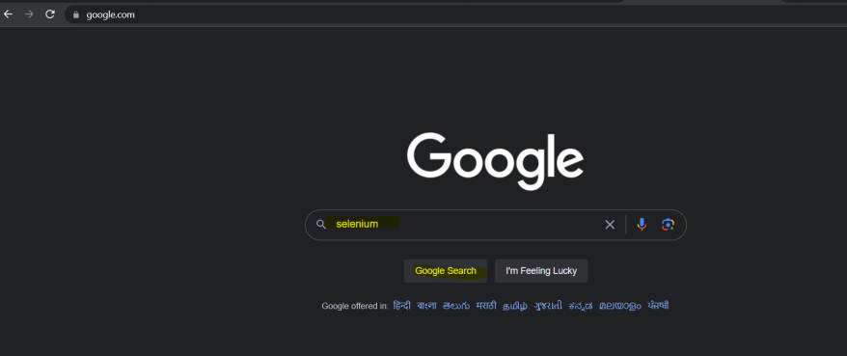

Question 2:

Launch the Firefox browser and open the URL "https://opensource-demo.orangehrmlive.com/web/index.php/auth/login".

Enter a valid username and password in the respective input fields.

Click on the "Login" button to submit the form.

Verify that the user is successfully logged in by checking if a welcome message is displayed on the page.

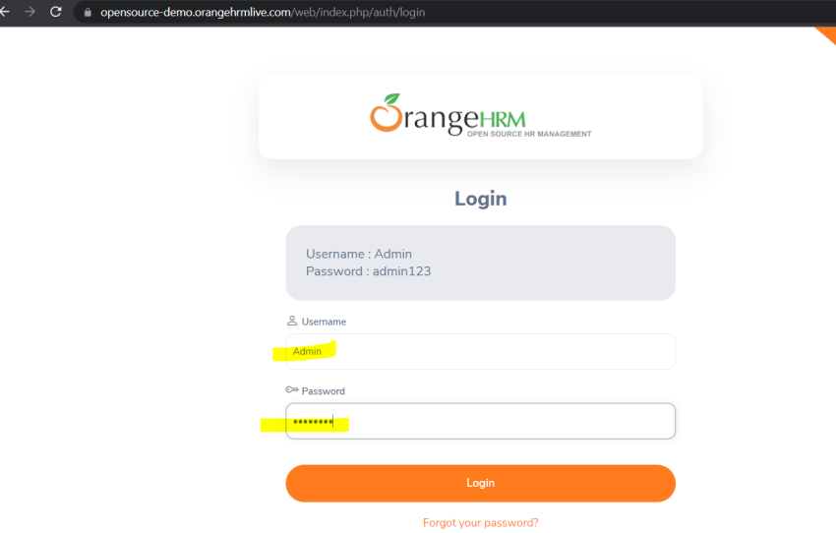

Question 3:

Launch the Chrome browser and open the URL "https://omayo.blogspot.com/".

Navigate to a dropdown menu on the left(Older Newsletter) and select an option with the value "doc1".

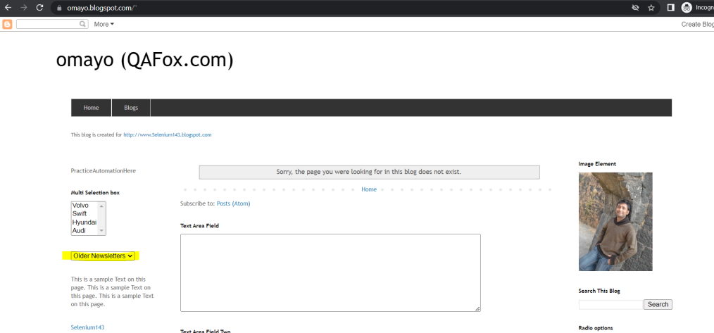

Question 4:

Launch the Chrome browser and open the URL "https://omayo.blogspot.com/".

Find all the links on the page and print their names

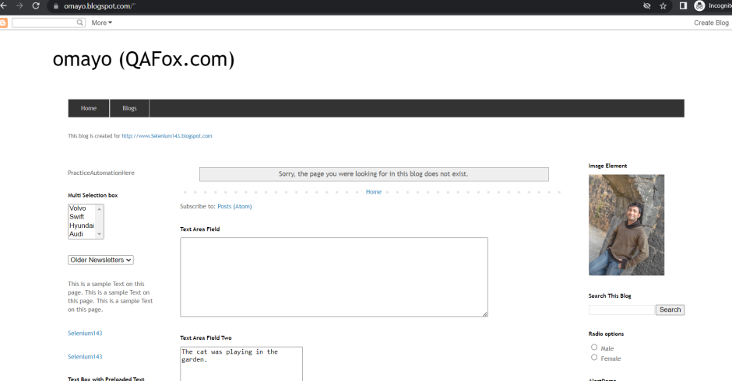

Question 5:

Launch the Chrome browser and open the URL: https://www.amazon.com

search for a product "Laptop", click on the first search result, and verify that the product title contains the word "Laptop".

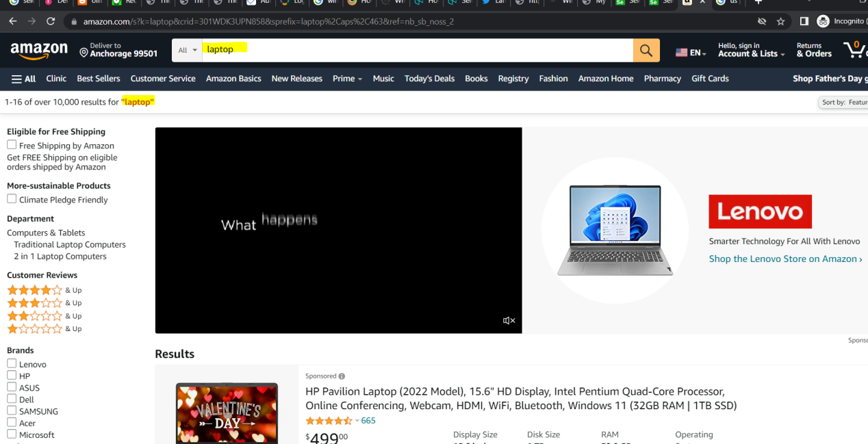

Question 6:

Launch the Chrome browser and open the URL "https://omayo.blogspot.com/".

Click ‘Click ToGetAlert’

Print the message of alert box “Hello”

Click Ok

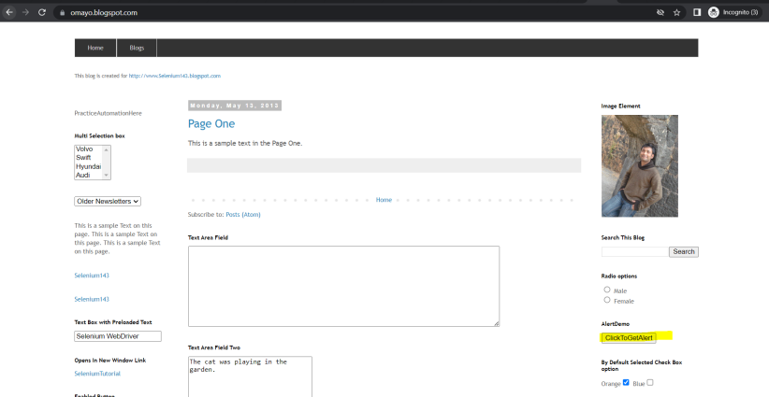

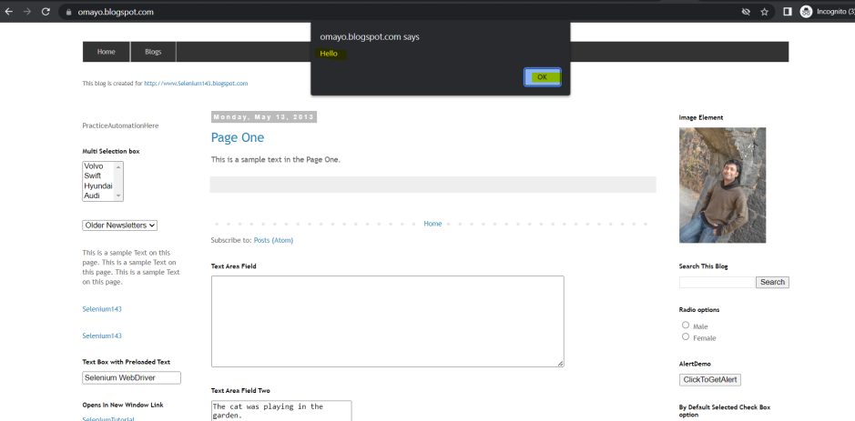

Question 7:

Launch Edge Browser and open the url “https://www.infoedge.in/”

Hover on Business Menu and click on Overview

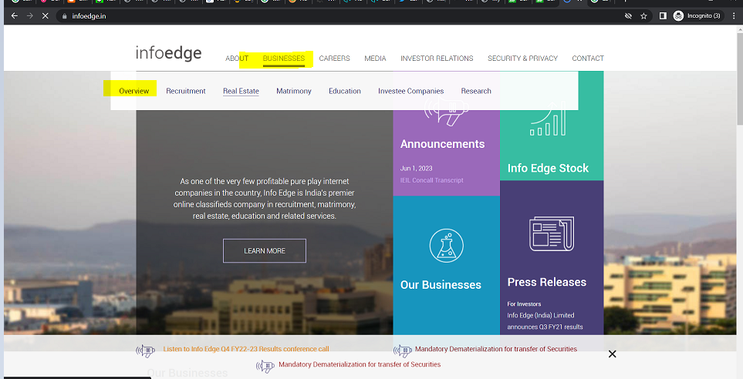

Question 8:

Launch Edge Browser and open the url “https://demo.automationtesting.in/Windows.html”

Click on ‘click’

Count total number of windows

Click on downloads in new window

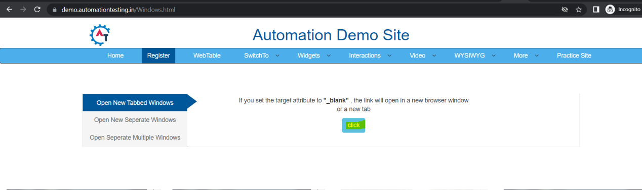

Question 9:

Launch Chrome Browser and open the url “https://practice.automationtesting.in/my-account/”

Click on ‘Lost Password’

Capture the message “Lost your password? Please enter your username or email address. You will receive a link to create a new password via email.” and print in console

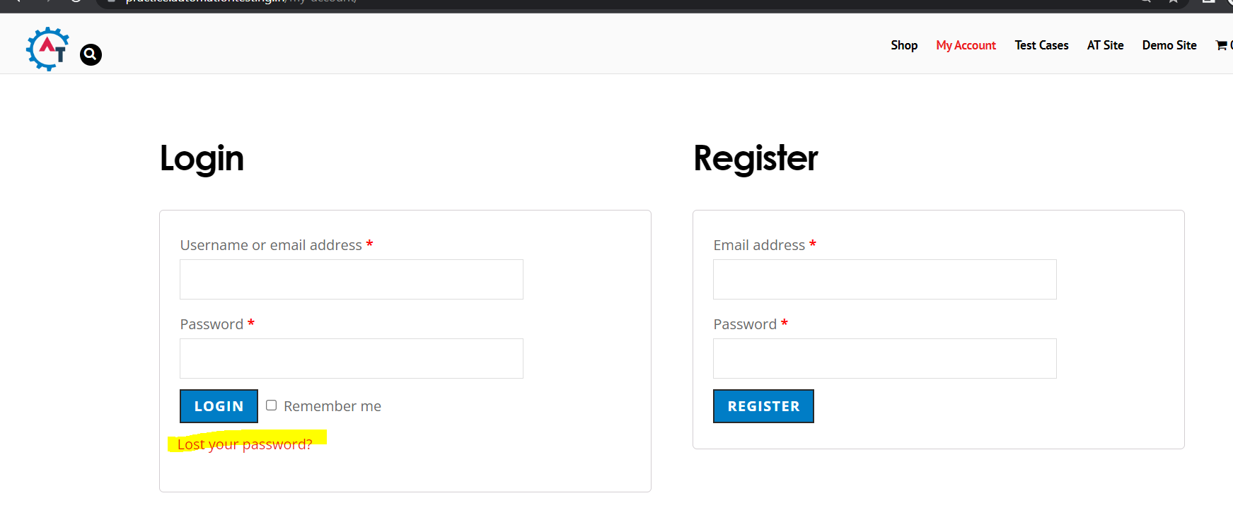

Question 10.

Launch Firefox Browser and open “https://practice.expandtesting.com/dropdown”

Go to Countries drop down

Count the total number of values in the drop down

Select each value once so that every value is drop down is selected( hint: use loop)

Print the entire playground table values in console

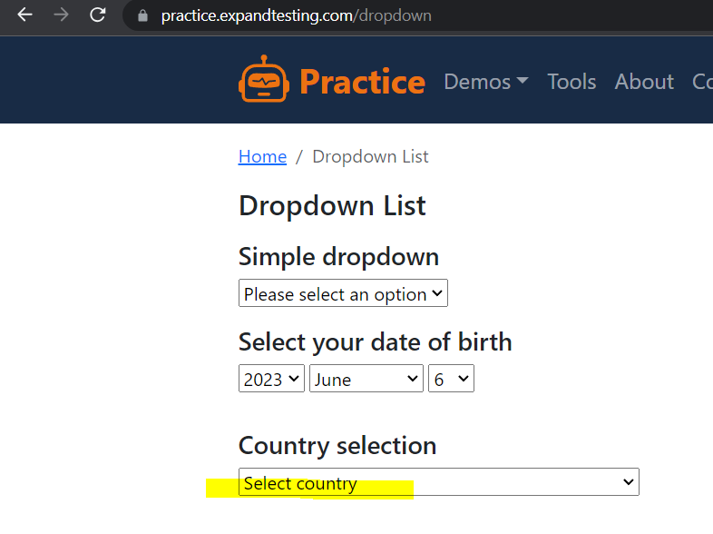

Question 11.

Launch Chrome Browser and open “https://practice.expandtesting.com/dynamic-table”

